11 Things You Need to Know Before Your Flight is Canceled

1. Envoy and Spirit Airlines Are Actually the Worst.
Spirit Airlines has a bad rap that is well-deserved.
Spirit Airlines doesn't have a great track record when it comes to flight cancelations, and delays should come as no surprise. Customers should expect to pay for those cheap fares in other ways -- one of which is the much higher than average chance of not arriving to their destination on time, or at all. In June, only 49.9 percent of the airline's overall reported flight operations arrived on time, according to the August 2015 Air Travel Consumer Report issued by the U.S. Department of Transportation (DOT). And 4.9 percent of its operations were canceled altogether -- a number surpassed only by Envoy, a regional affiliate of American Airlines, which had 5.2 percent of operations canceled.
Consumers can limit their exposure to cancelled and delayed flights by avoiding flying on regional jets, which tend to be canceled more often than larger planes. American Airlines, had 1.1 percent of operations canceled. For on-time flights, American came in eighth out of the 12 airlines ranked in the report -- one ahead of United.

2. Hawaiian, Alaska, and Delta Airlines Are the Best. 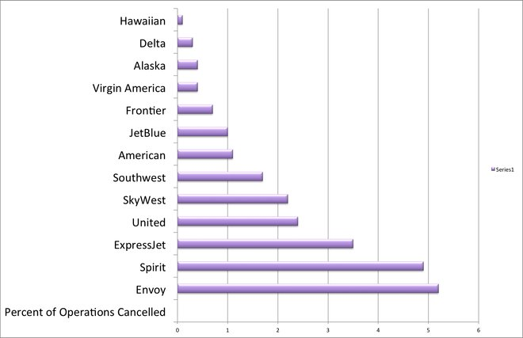

Percentage of flight operations canceled by carrier in June, according to data released by the U.S. Department of Transportation
The carriers with the fewest cancellations in June were also the carriers with the most on-time flights. For on-time flights, Hawaiian Airlines came in first, followed by Alaska and the once-hated but now much-improved Delta.
As we show in our airline performance rankings, some airlines are better at on-time performance (notably, lately, Delta), and at not overbooking. In terms of cancelled flights in June, Alaska had .4 percent, Delta .3 percent, and Hawaiian just .1 percent.

3. It Might Be Wise to Avoid a Layover in Chicago O'Hare.
Chicago O'Hare International Airport is one of the country's busiest airports -- and it had one of the worst track records in June for on-time arriving and departing flights, according to the DOT report. Only 66.2 percent of arriving flights were on time, and 63.8 percent of departing flights. Compare that to Hartsfield-Jackson Atlanta International Airport, an even busier airport that managed to have 80.1 percent of flights arrive on time and 76.2 percent depart on time, and it's easy to see that Chicago's numbers aren't too great.

4. Airlines Are Doing a Worse Job of Making Customers Happy This Year.
There were more consumer complaints filed with the Aviation Consumer Protection Division this year: they have risen significantly -- specifically, they're up 20.3 percent in the first six months of this year compared to the first six months of last year. So if you've become accustomed to a smooth flying experience, it may be time to get ready for a bumpy ride.

5. You Are Entitled to Compensation If You are Bumped from a Flight.
If you are bumped from a flight involuntarily due to overbooking, the airline owes you money, even if they rebook you on a later flight. If your rebooked flight arrives at your destination one to two hours later, the airline still owes you an amount equal to 200 percent of your one-way fare (with a $650 maximum), according to DOT rules. If you get to your destination more than two hours later (or more than four hours later for international flights), you are entitled to 400 percent of the price of your one-way fare, up to $1,300.

6. But Not if Your Flight is Delayed or Canceled.
Airlines don't have to put you up for the night if your flight is canceled, and many choose not to. If your flight is delayed or canceled, the airline owes you squat. Some may choose to provide food vouchers or hotel accommodation, but it's entirely at their discretion. When my American Airlines flight was cancelled, we did get food vouchers but not a hotel voucher.
Many airlines have set policies in place that can be found on their websites; United for example says, it may offer free hotel accommodations for delays that exceed four hours between 6 p.m. and 4 a.m. if the delay or cancelation was within its control. Alternatively, American Airlines only provides a "distressed passenger rate" voucher for a discounted hotel room when the cancelation is due to bad weather. So when the cancelation was American Airlines' fault passengers can expect to figure out their own sleeping arrangements.

7. Most Flights Are Delayed Because of a Late-Arriving Aircraft.
Less than one percent of flights in June were delayed because of extreme weather; far more were delayed because of operational failures by the airline.
As noted, the cause of the delay is an important factor in what compensation the airline might offer you. So it's a good idea to understand what causes them most often. According to the DOT report, an average of 74.8 percent of flights were on time in June, 8.8 percent suffered a delay to a late-arriving aircraft, 7 percent were delayed because of an air carrier delay (read: something that was the airline's fault, such as maintenance or crew problems), and 6.3 percent were due to a National Aviation system delay (something like heavy traffic volume at the airport or another airport operation issue). Just .9% were due to an extreme weather delay, a comparatively low number.
Knowing that, American Airlines' policy of only providing discounted hotel rooms for cancellations due to weather seems a lot less generous (and for them, certainly less expensive) than United's policy of providing free hotel rooms for air carrier delays.

8. Your Domestic Flight Shouldn't Get Stuck on the Tarmac for More than Three Hours.
If it is delayed longer than that, expect to get sent back to the gate.
Unless the pilot deems there is a security concern, or air traffic control believes that returning to the gate would significantly disrupt operations, your domestic flight is not allowed to stay on the tarmac for more than three hours. And the flight attendants must provide you with food and water after two. And yes, you must be allowed to use the bathrooms.

9. Avoid Checking a Bag if You Possibly Can, Especially on Envoy.
After our flight fiasco, we didn't see our bags again for several days. We got them eventually, but it's good to know that some airline carriers have a better track record with your baggage than others. Unsurprisingly, good ole Envoy Air has the worst record with mishandled bags in June, with 10.5 reports per 1,000 passengers ("mishandling" meaning bags that were lost, delayed, damaged, or pilfered). American Airlines was fourth worst, with 4.3 reports per 1,000 passengers.

10. If Your Bags Are Permanently Lost, You Will Get Compensated -- But Expect It to Take a While.
If the airline loses your bag, they do have to compensate you, but expect to haggle over the value of your goods and wait four weeks to three months to get paid. If the airline deems a passenger claim exaggerated they may deny it altogether. Receipts will help you prove the value of your lost belongings.

11. Don't Just Wait in Line at the Airport -- Call Customer Service, Too.
After your flight is canceled, move to the customer service desk, but also call the customer service number while you are waiting in line. This will almost always result in quicker service, and as you are competing against the other passengers to rebook the best remaining flights, time is of the essence. You may not want to step out of the line altogether, though; if there are food or hotel vouchers on offer, you can't get those over the phone.
Aug 14, 2015 by Kelsey Blodget Oyster.com)

